**Homework 7**

Department of Mechanical and Aerospace Engineering

University of California, San Diego

MAE 150

Lawrence Custodio

A08739279

14 March 2013

Happy 3.1415926535 8979323846 2643383279 5028841971 6939937510 5820974944 5923078164 0628620899 8628034825 3421170679 Day

**Problem 2:**

A) Determine $θ_{3} and θ_{4 }$ as a function of $θ_{2}$.



B) Plot the trajectory of Points A and B



C) Calculate the angular velocities $\dot{θ_{3}}$ and $\dot{θ_{4}}$ as a function of $θ_{2}$



**Problem 3:**

Trace Path

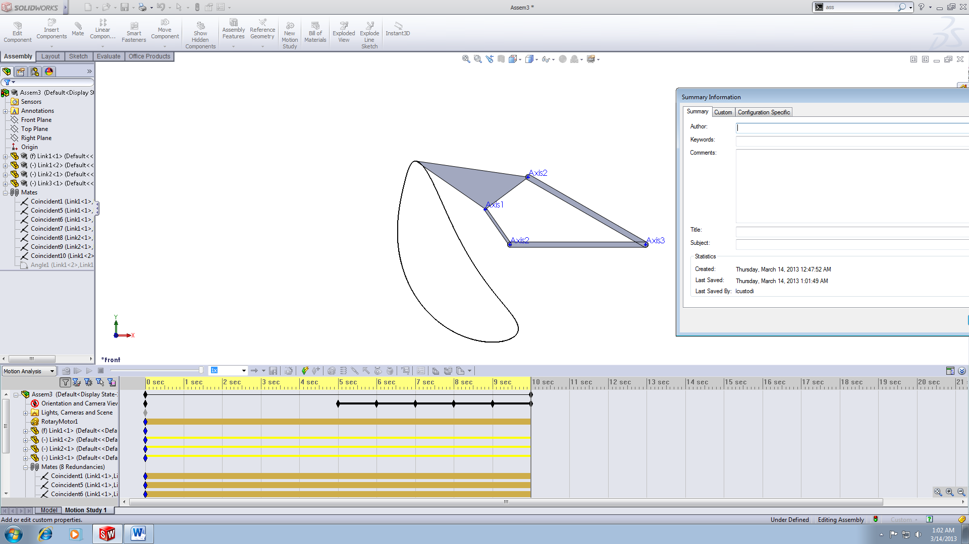

Displacement Magnitude

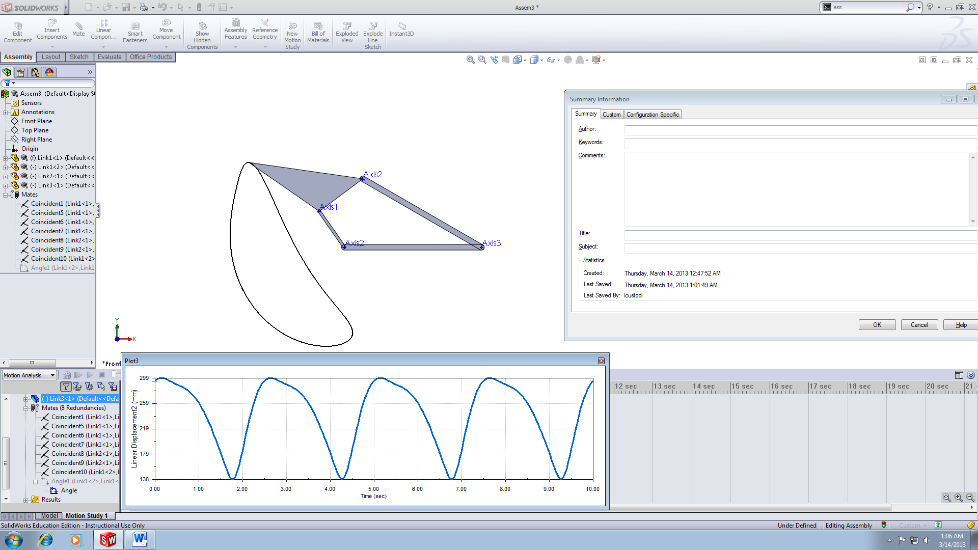

Velocity Magnitude

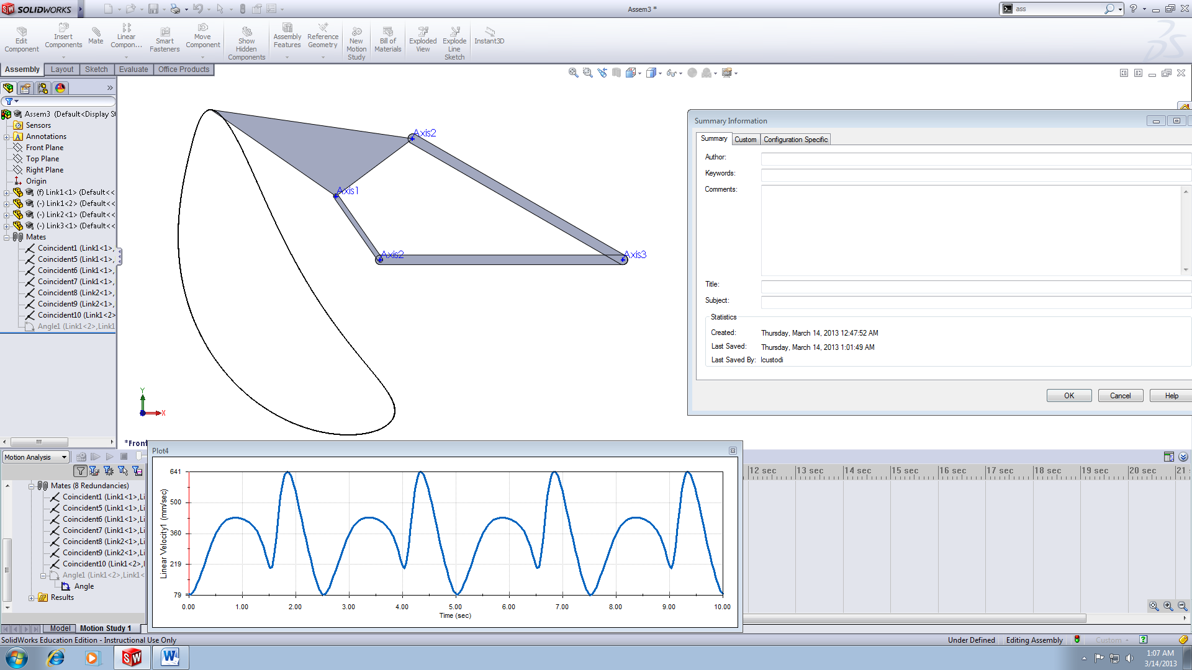

**Appendix:**  
Problem 2

clc;clear;close all;

%Lawrence Custodio

%HW 7 Problem 2

%Given Parameters:

l1 = 1; l2 = 1; l3 = 1.1; l4 = 0.9; l5 = 1;

t1 = 0.05; t2 = 0.08;

the = 60:.4:100; ta = 99.6:-.4:60;

theta2 = [the ta];

%Part A - Find theta3=f(theta2) and theta4=f(theta2)

L1 = l1/l4; L2 = l1/l2; L3 = (l2^2-l3^2+l4^2+l1^2)/(2*l2*l4); %dimensionless params

for j = 1:length(theta2)

error = .1; %set error valu

eps = 1;

theta4(1) = 40; %Set initial guess

%Freudenstein condition/equation to find theta4(j)

k = 1; %theta4 indexing for Freudenstein

while eps>error

theta4(k+1) = acosd((L2^-1)*(L1*cosd(theta2(j))-L3+cosd(theta2(j)-theta4(k))));

eps = abs(theta4(k+1)-theta4(k));

k = k+1;

end;

theta4(j)=theta4(k);

%Finding theta3(j)

theta3(j) = acosd((-l2*cosd(theta2(j))+l4*cosd(theta4(j))+l1)/l3);

end

plot(theta2(101:end),theta4(101:end),'r')

hold on

plot(theta2(101:end),theta3(101:end))

title('Freudenstein Approach: \theta_3/\theta_4 vs \theta_2,')

legend('\theta_4','\theta_3')

xlabel('\theta_2 [\circ]')

ylabel('\theta [\circ]')

%Part B - Plot trajectory of A and B, see handout

%Trajectory @ Pt.A:

for A=1:length(theta2)

h = t2;

hn = l5;

xA(A) = l2.*cosd(theta2(A)) + h.*cosd(theta3(A)) - hn.*sind(theta3(A));

yA(A) = l2.*sind(theta2(A)) + h.*sind(theta3(A)) + hn.*cosd(theta3(A));

end

%Trajectory @ Pt.B:

for B=1:length(theta2)

h = .5*l3;

hn = t1;

xB(B) = l2.*cosd(theta2(B)) + h.*cosd(theta3(B)) - hn.*sind(theta3(B));

yB(B) = l2.*sind(theta2(B)) + h.*sind(theta3(B)) + hn.*cosd(theta3(B));

end

figure

plot(yA,xA,'r')

hold on

plot(yB,xB)

set(gca,'Xdir','reverse');

title('Trajectory of Points A and B')

legend('Point A','Point B')

xlabel('Y [m]')

ylabel('X [m]')

%Part C - Angular velocities

om2=5/pi;

for i=1:length(theta2)

om3(i)= om2*(l2/l3)*sind(theta2(i)-theta4(i))/sind(theta3(i)+theta4(i));

om4(i)= om2*(l2/l4)*sind(theta3(i)+theta2(i))/sind(theta3(i)+theta4(i));

end

figure

plot(theta2(101:end),om3(101:end),'r')

hold on

plot(theta2(101:end),om4(101:end))

title('Angular velocity of \theta_3 and \theta_4')

legend('\omega_3','\omega_4')

xlabel('\theta_2 [\circ]')

ylabel('\omega [Rad/s]')